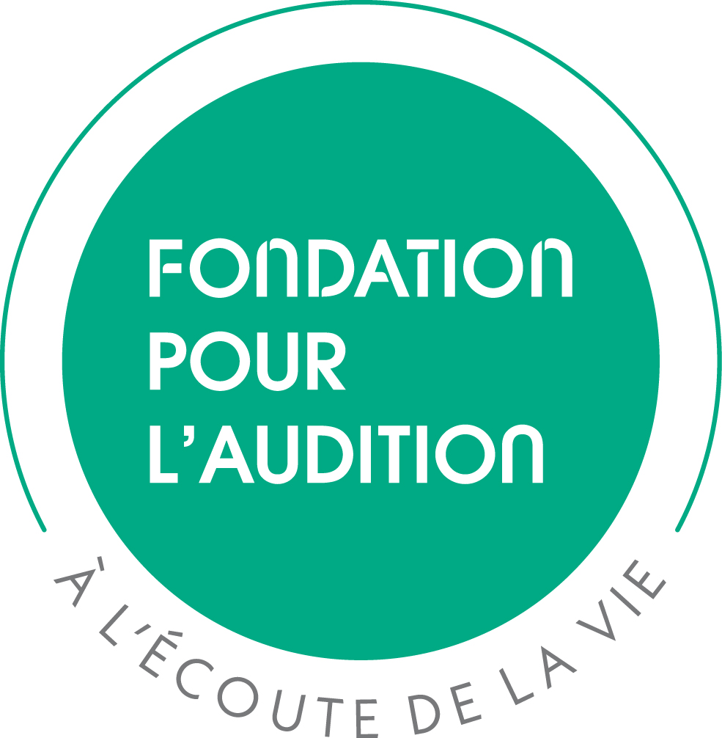

BEST PUBLICATION OF THE YEAR 2025
EXECUTIVE RY
FONDATION POUR L’AUDITION - 13, rue Moreau - 75012 Paris, France. ': (+33) 1 55 78 20 10 research@pourlaudition.org

Submission deadline: May 19, 2026 @ research@pourlaudition.org

FIRST AUTHOR OF THE PUBLICATION

Name of applicant: |  | Position:
Degree(s): |  | Date of birth:
Professional address:
Phone: | E-mail:

LABORATORY / INSTITUTION WHERE THE WORK WAS CONDUCTED

Name of the laboratory:

Name of the supervisor: |  | Position/title:
Address:
Phone: | E-mail:

PUBLICATION (attach as PDF file)

Full reference:

Short title of your presentation:

CONTRIBUTIONS OF THE FIRST AUTHOR TO THE PUBLICATION

LAY SUMMARY (Describe your main discovery; 200 words max for each summary in French and English)

NOVELTY / IMPACT OF THE DISCOVERY

COMMENTS (if applicable)

NAME OF APPLICANT: NAME OF SUPERVISOR:
DATE & SIGNATURE: DATE & SIGNATURE :
FIRST AUTHOR BIOGRAPHICAL SKETCH
Half-page max

Name & Degree: Position:
ORCID iD number:

A. Education, Training, Positions & Honors

B. Scientific contributions
List your most significant contributions (articles, patents, books…) in chronological order, beginning from the most recent ones, within the page limit.

C. Past FPA-funded projects and related publications0F

BEST PUBLICATION OF THE YEAR 2025

POLICIES & GUIDELINES

Fondation Pour l’Audition, hereinafter referred to as “FPA”, supports scientific research in Hearing Sciences with the ultimate goal of improving hearing health. FPA is committed to support excellence in hearing research by awarding scientific prizes, such as the “Best publication of the year” Prize (hereinafter referred to as “the Prize”).

Article I. Objective of the call
The FPA “Best publication of the year” Prize is awarded annually to two young investigators in recognition of the excellence and impact of his/her work in Hearing. The Prize will honor major research discoveries, either clinical or basic, in the field of Hearing. FPA welcomes applications related to topics in hearing sciences, auditory neurosciences, brain imaging, disability, speech…

The “Best publication of the year” Prize are divided in 2 categories as follows:
- one prize recognizing a significant work in basic science, and
- the second prize recognizing a significant work in clinical research.

Article II. Eligibility
The Prize is open to young investigators meeting the following criteria:
- The work related to the publication must have taken place in a French laboratory
- If the applicant is/was a graduate student, he/she was or is currently registered to a French “Ecole doctorale” at the time of the research work
- If the applicant is/was a postdoctoral fellow, he/she was or is currently employed by a French academic or clinical public research institution at the time of the research work
- He/she must holds a PhD degree for 8 years at the most.

Publications eligible to the call for applications are limited to original articles published in a peer-review journal and must be available online at the time of application. Preprints, reviews, master or PhD dissertations are ineligible as well as articles published in predatory journals.

Applications must comply with FPA’s mission to improve hearing health and promote translational research. Publications involving a member of the FPA Scientific Committee or Board of Directors and their laboratory/clinical department are not eligible for an FPA prize.

Article III. Preparing your application
Prepare the application in English using the Word form available at https://www.fondationpourlaudition.org/scientific-prizes-786-en. No other form will be accepted.
Most of the sections in the application form are self-explanatory. The page numbering is set automatically.

First author BioSketch Form (1/2-page max)
- Education, Training, Positions and Honors
List in chronological order your education, training, current and previous positions, beginning with your present position. Include start/end dates, position title, name of organization and department. In case of non-permanent/non-tenure or fixed term position, state the term of the current contract.
Select and list professional memberships and academic/professional honors received.
- Scientific contributions
List your most significant contributions in chronological order beginning from the most recent ones (limited to 10 per applicant).

Article IV. Submitting your application

4.1 Electronic submission
The application (2 MB max) must be submitted electronically as a single PDF file (form + publication) through the e-submission portal at https://www.fondationpourlaudition.org/scientific-prizes-786-en by May 19, 2026 midnight (Central European Time).

4.2 General considerations
Incomplete applications, applications not complying with the FPA policies or applications with false statements will be administratively withdrawn. Any misleading or false statements will render the application null and void. Late applications will not be accepted.

4.3 Acknowledgment of receipt
Upon receipt of the electronic copy of the pre-proposal by FPA, the appplicant and his/her supervisor will receive an acknowledgment of receipt to the e-mail addresses listed in the application.

Article V. Peer review process
The FPA policies are intended to ensure that applications are evaluated on a fair and timely process, free of bias.

5.1 Admissibility and review process
FPA verifies the admissibility of applications and compliance with the present FPA policies. Compliant applications will be evaluated by the FPA Scientific Committee.
The FPA Scientific Committee will select the two laureates of the Prize as the two reaching the absolute majority of votes in their respective categories (i.e., clinical or basic science). In the event of a tie, the chair of the FPA Scientific Committee will have the casting vote.

5.2 Evaluation criteria
The FPA Scientific Committee will review the applications using the following evaluation criteria:
- The quality of the applicant and their expertise, past experiences and achievements
- The originality, novelty, quality and excellence of the publication
- The impact of the candidate’s research on hearing health
- The relevance to FPA’s mission to improve hearing health and promote translational research.

The FPA Scientific Committee is sovereign in its deliberations, which are confidential and not subject to any appeal in any way. If the quality of the applications does not meet the FPA requirements, the FPA Scientific Committee is free to dismiss all the applications and not award any prize.
The award recipients proposed by the FPA Scientific Committee are subjected to the approval of the FPA Board of Directors.

5.3 Breach of review
Applicants, as well as their institution’s representatives, may not contact any member of the FPA Scientific Committee regarding their application during the review process.
Failure to comply with this policy will create serious breaches of confidentiality and conflicts of interest in the peer review process that will lead to the administrative rejection of the application.
Members of the FPA Scientific Committee are required to notify FPA if they are contacted by an applicant.

Article VI. Award considerations

6.1 Prize amount
Each Prize is awarded to the laureate, not the supervisor or their laboratory. The amount of each Prize is set to ten thousand euros (10,000 €) per prize divided into 2 parts:
- Personal prize of 5,000 € (subject to tax regulation), and
- Professional prize of 5,000 € to present their research work in scientific meetings or to visit a research lab.

6.2 Prize conditions
The Prize will be awarded to the two laureates subjected to:
- the signature of the FPA Charter of Commitments by each laureate,
- the presence of the laureates and their supervisors at the award ceremony and keynote lecture of the Scientific Grand Prize laureate in March 2027 in Paris, France. FPA may replace both events by e-events and modify their dates if required but the laureates’ and supervisors’ commitment shall remain the same.
- A short presentation of the published work by the laureates and their supervisors during the keynote lecture of the Scientific Grand Prize laureate on March 2027 in Paris, France.

Article VII. Suspension, cancellation or adjournment of the call
If circumstances require it or for reasons beyond its control, FPA reserves the right to modify the present policies or to suspend, cancel or adjourn the organization of the call for applications without affecting its liability. Also, the prize competition will be cancelled if only one application is received. However, the Prize may no longer be cancelled after the plenary meeting of the FPA Scientific Committee held to select the laureate, unless the FPA Scientific Committee is unable to get to the Prize ceremony due to unforeseen circumstances.

Article VIII. Key dates
Launch of the call March 2026
Application deadline for full proposals May 19, 2026
Award notification July 2026
Award activation March 2027
Deadline for grant agreement signature March 2027

Article IX. Support
For assistance, contact FPA at FONDATION POUR L’AUDITION – 13, rue Moreau – 75012 Paris, France.
e-mail: research@pourlaudition.org

If your application is awarded by FPA. Both first author and supervisor must be present for the presentation at an FPA event
Document PMID / DOI and PDF file for accepted publications
See list of non-predatory journals recommended by the French Conference of Deans at https://conferencedesdoyensdemedecine.org/la-conference-des-doyens-de-medecine-et-du-cnu-sante-luttent-contre-les-revues-predatrices/
https://www.fondationpourlaudition.org/fondation-pour-laudition-778-en
Costs related to the travel and accommodation of the laureate will be covered by FPA.

