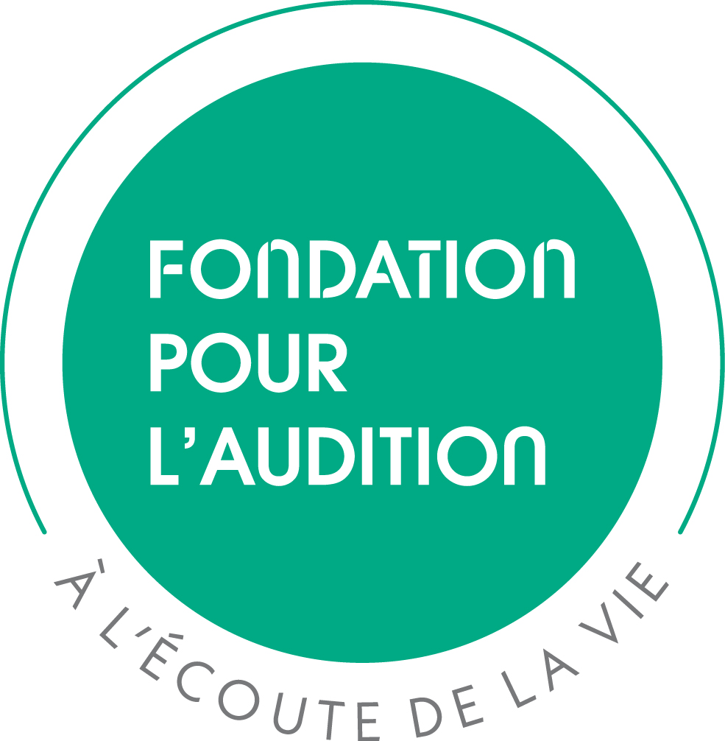

EXECUTIVE RY
FONDATION POUR L’AUDITION - 13, rue Moreau - 75012 Paris, France. ': (+33) 1 55 78 20 10 research@pourlaudition.org

2026 PRE-PROPOSAL APPLICATION

TITLE of the PROJECT:

Individual project Collaborative project YEARS of SUPPORT: 1 2 3

The undersigned have reviewed the present application, certify the statements herein are true, complete and accurate, have read the policies of FONDATION POUR L’AUDITION concerning research support and accept to comply with such policies if the present application is awarded.
PRINCIPAL INVESTIGATOR |  |  | Name: |  |  | Degree(s):
Position: |  | Institution: |  |  | Department:
Address:
Phone: | E-mail:
Head of the LABORATORY/INSTITUTE |  |  | Name:
Phone: |  |  |  | E-mail:
LEGAL GRANT OFFICER |  |  | Name:
Institution: |  |  |  |  | Department:
Address:
Phone: | E-mail:

CO-INVESTIGATORS (if applicable)

CO-INVESTIGATOR 1 (TEAM B) |  | Name: |  |  |  |  | Degree(s):
Position: |  | Institution: |  |  |  | Department:
Address:
Phone: | E-mail:
Head of the Department (TEAM B)
Phone: |  |  |  |  | E-mail:
LEGAL GRANT OFFICER for TEAM B |  |  | Name:
Institution: |  |  |  | Department:
Address:
Phone: |  |  | E-mail:
CO-INVESTIGATOR 2 (TEAM C) |  | Name: |  |  |  |  | Degree(s):
Position: |  | Institution: |  |  |  | Department:
Address:
Phone: | E-mail:
Head of the Department (TEAM C) |  |  | Name:
Phone: |  |  |  |  | E-mail:
LEGAL GRANT OFFICER for TEAM C |  |  | Name:
Institution: |  |  |  | Department:
Address:
Phone: |  |  | E-mail:

PROJECT DESCRIPTION
Do not exceed 1 page. Use Arial font size 11 point with line spacing of 1.15. No appendices allowed.

PRINCIPAL INVESTIGATOR’S BIOGRAPHICAL SKETCH – TEAM A
One page max

Name & Degree: Position:
ORCID iD number:

A. Education, Training, Positions & Honors

B. Scientific contributions
List your most significant contributions (articles, patents, books…) in chronological order, beginning from the most recent ones, within the page limit.

C. Past FPA-funded projects and related publications0F

CO-INVESTIGATOR’S BIOGRAPHICAL SKETCH – TEAM B
One page max

Name & Degree: Position:
ORCID iD number:

A. Education, Training, Positions & Honors

B. Scientific contributions
List your most significant contributions (articles, patents, books…) in chronological order, beginning from the most recent ones, within the page limit.

C. Past FPA-funded projects and related publications1F

CO-INVESTIGATOR’S BIOGRAPHICAL SKETCH – TEAM C
One page max

Name & Degree: Position:
ORCID iD number:

A. Education, Training, Positions & Honors

B. Scientific contributions
List your most significant contributions (articles, patents, books…) in chronological order, beginning from the most recent ones, within the page limit.

C. Past FPA-funded projects and related publications2F

CALL for RESEARCH PROPOSALS LABORATORIES

2026 POLICIES & GUIDELINES

Fondation Pour l’Audition, hereinafter referred to as “FPA”, supports scientific research in Hearing with the ultimate goal of improving hearing health and discover solutions for people with hearing disorders.
The aim is to support new approaches, to promote multidisciplinary research and, more broadly, to implement innovations and outcomes in order to improve hearing health in the short or long term.

Article I. Objective of the call
Awarded to laboratories, professional or scholar societies and associations, FPA laboratory research grants aim to promote French scientific excellence and cover laboratory expenses for up to 3 years.
By stimulating new approaches and combining them with excellence, FPA wishes to promote innovations that will improve our hearing health in the future and contribute to France’s influence in Hearing Sciences.

Article II. Eligibility
FPA grants are awarded to teams in academic, clinical, public research institutions, professional or scholar societies and associations.
The project must be coordinated by a French principal investigator from a French institution and involve teams in French institutions, but may include foreign collaborators.
The principal investigator and co-investigators must hold a faculty appointment (position equivalent to assistant professor or higher) in order to be eligible for a grant from FPA.
Applications must comply with FPA’s mission to improve hearing health and promote translational research.
Laboratories are ineligible for funding if they hold an active FPA award at the launch of the call. Projects involving a member of the FPA Scientific Committee or Board of Directors and their laboratory/clinical department are not eligible for an FPA research grant.

Article III. Scope of research
Hearing research including basic research, technical innovation, rehabilitation, ...
Any projects with the long-term goal of improving the daily lives of people with hearing disorders.
Applications from researchers external to the field are encouraged.

Article IV. Preparing your pre-proposal
Pre-proposals are used to evaluate whether the project is within the scope of our research mission.
Prepare the application using the 2026 Word form available at https://www.fondationpourlaudition.org/call-for-proposals-laboratories-783-en. No other form will be accepted.
Read and follow the instructions carefully.
The document must be filled out in English ONLY and must comply with the format specifications and page limits detailed in this document. Do not reformat the forms or exceed the space provided in the different sections of the application. Failure to comply will result in administrative withdrawal. Decisions of administrative withdrawal are final and not subject to appeal.

4.1 Privileged Communication
Material and information provided by the applicant in the application are considered privileged communication.

4.2 General instructions
Most of the sections in the application form are self-explanatory. The page numbering is set automatically.
The PI of a collaborative project will be the contact and overall manager of the project.
A member of the PI lab cannot apply as co-investigator. Collaborators requesting funding from the FPA grant must be listed as co-investigators. Collaborators not requesting a budget from the FPA do not qualify as co-investigators but can be mentioned in the project description of the application.
The legal grant officer must be the head of sponsored projects from the institution. Failure to comply at the time of submission will result in administrative withdrawal.

4.3 Specific instructions
Title of the project
The title should not exceed 20 words.

Project description Do not exceed 1 page.
- Font: Use Arial font size 11 point with line spacing of 1.15.
- Page format: Use A4 page format with margins of 1.5 x 1.5 x 1.5 x 1.5 cm.
Adherence to font and margin requirements is necessary. If terms are not universally known, spell out the term for the first time it is used and note the appropriate abbreviation in brackets. The abbreviation may be used thereafter.

PI/Co-Investigator BioSketch Form (1 page max)
Your CV will be used to confirm eligibility and to assess your ability to carry out the proposed work.
- Education, Training, Positions and Honors
List in chronological order your education, training, current and previous positions, beginning with your present position. Include start/end dates, position title, name of organization and department. In case of non-permanent/non-tenure or fixed term position, state the term of the current contract.
Select and list professional memberships and academic/professional honors received.
- Scientific contributions
List your most significant contributions in chronological order beginning from the most recent ones (limited to 10 per investigator).

- Notice of approval from ethics committees
If human or animal subjects are involved in the project, notice of approval from the relevant ethical committees are required3F. As the time to obtain the approval may be long, notice of submission to ethical committees is not mandatory at the time of application. However, if the project is approved by FPA, the formal notice of approval from the ethics committee is required prior to September 30, 2027 (sponsor4F agreements are not accepted). Failure to comply will result in the cancellation of the funding.

Article V. Submitting your pre-proposal

5.1 Electronic submission
The application (2 MB max) must be submitted electronically as a single PDF file through the e-submission portal at https://www.fondationpourlaudition.org/call-for-proposals-laboratories-783-en by February 16, 2026 midnight (Central European Time). At this stage, no signatures are required.

5.2 General considerations
Incomplete applications, applications not complying with the FPA policies or applications with false statements will be administratively withdrawn. Late applications will not be accepted.

5.3 Acknowledgment of receipt
Upon receipt of the electronic copy of the pre-proposal by FPA, the investigators and their legal grant officers will receive an acknowledgment of receipt to the e-mail addresses listed in the application.

5.4 Maximum submissions
Only one pre-proposal application is allowed per team. The same application cannot be resubmitted more than 2 times.

Article VI. Peer review process
The FPA policies are intended to ensure that applications are evaluated on a fair and timely process, free of bias.

6.1 Admissibility
FPA verifies the admissibility of the pre-proposals and compliance with the present FPA policies.
Compliant pre-proposals are then submitted for review to the FPA Scientific Committee, composed of international scientists chosen for their expertise related to Hearing Sciences. To view the list of the FPA Scientific Committee members, visit: https://www.fondationpourlaudition.org/fondation-pour-laudition-778-en.

6.2 Evaluation criteria
Pre-proposal evaluation
The FPA Scientific Committee will review the pre-proposals using the following evaluation criteria:
- The relevance to FPA’s mission to improve hearing health and promote translational research
- The novelty and feasibility of the research project
- The expertise of the laboratory
- The acknowledgement in scientific publications related to past FPA grants.

Based on these criteria, the FPA Scientific Committee will select the applicants invited to submit a full proposal during a meeting.

The FPA Scientific Committee is sovereign in its deliberations, which are confidential and not subject to any appeal in any way by the investigators or representatives of their corresponding institution.

If the quality of the pre-proposals does not meet the FPA requirements, the FPA Scientific Committee is free to dismiss all the applications and not award any grant in the framework of the 2026 call for applications.
Approval of the pre-proposal is mandatory in order to submit a full proposal.

6.3 Breach of review
Applicants, as well as their institution’s representatives, may not contact any member of the FPA Scientific Committee regarding their application during the review process.
Failure to comply with this policy will create serious breaches of confidentiality and conflicts of interest in the peer review process that will lead to the administrative rejection of the application.
Members of the FPA Scientific Committee are required to notify FPA if they are contacted by an applicant.

Article VII. Award considerations

7.1 Award amount
The maximal award the project could receive is 65,000 euros for years 1 and 2, and 70,000 € for year 3 (all taxes included).

7.2 Award activation
The date for the award activation will be decided by the applicant in agreement with his/her institution but cannot be set prior to October 1, 2026.

Article VIII. Suspension, cancellation or adjournment of the call
If circumstances require it or for reasons beyond its control, FPA reserves the right to modify the present policies or to suspend, cancel or adjourn the organization of the 2026 call for research proposals without affecting its liability.

Article IX. Key dates
Launch of the 2026 call for pre-proposals December 2025
Electronic application deadline for pre-proposals February 16, 2026 (midnight)
Invitation to submit full proposals March 16, 2026
Electronic application deadline for full proposals April 15, 2026
Deadline for reception of the original printed application April 23, 2026
Award notification July 2026
Award activation October 1, 2026
Deadline for formal approval from the ethics committee September 30, 2027
Deadline for grant agreement signature September 30, 2027

Article X. Support
For assistance, contact FPA at FONDATION POUR L’AUDITION – 13, rue Moreau – 75012 Paris, France.
e-mail: research@pourlaudition.org

Document PMID / DOI and PDF file for accepted publications
Document PMID / DOI and PDF file for accepted publications
Document PMID / DOI and PDF file for accepted publications
i.e. ANSM, CPP, Comité d’Ethique en Expérimentation Animale, Autorisation de projet utilisant des animaux à des fins scientifiques” from the Ministère de l’Enseignement Supérieur, de la Recherche et de l’Innovation, …
The French equivalent of “sponsor” is “promoteur”

